**Employee Attrition Prediction Report**

***By Srashti Tiwari, April 09, 2024***

**Aim**: This project aims to provide insights into the factors influencing employee attrition and predict which employees are likely to leave the company.

**Problem statement:** Acme Corporation, a leading tech company, is facing a significant challenge with employee turnover. The HR department is concerned about the increasing rate of attrition, as it negatively impacts team dynamics, project continuity, and overall company morale. To address this issue, Acme Corporation wants to leverage data analytics and machine learning to understand the factors influencing employee turnover and predict which employees are likely to leave shortly.

**Dataset:** Acme Corporation has provided historical data on employee demographics, job satisfaction, work environment, performance metrics, and turnover status. This dataset spans the last five years and includes information on employees who have left the company and those who are still currently employed. Following is a sample row*-*



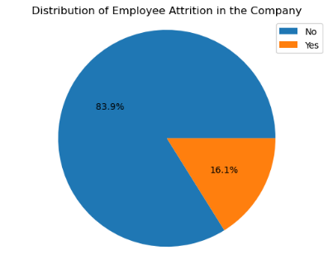

Analysis & Interpretation: The target value Attrition is a categorical variable with the values ‘Yes’ and ‘No.’ The dataset is highly imbalanced and contains significantly more examples for ‘No’ than ‘Yes’.

**Below is the Power BI dashboard for employee attrition explained through various features:**

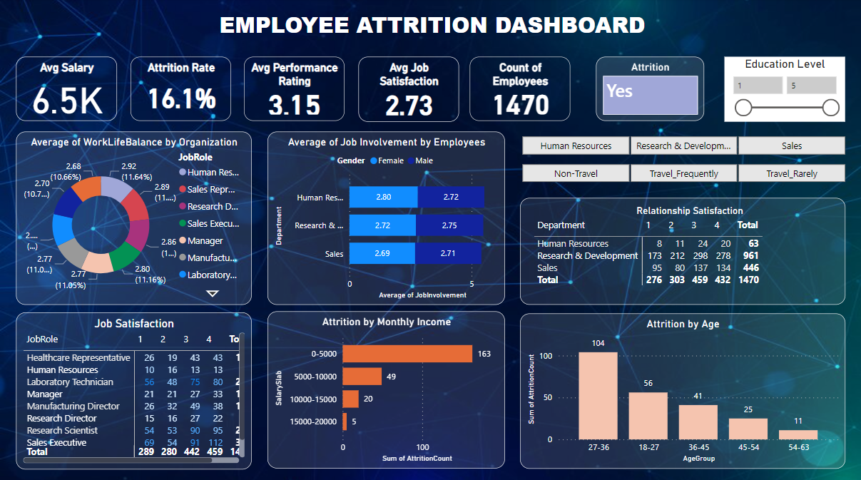

Based on a total number of 1470 employees, the overall attrition rate is 16.1%. The company’s average salary is 6.5k. While those belonging to the human resource department who travel frequently show the highest attrition rate of 36.4%. Their average salary is 5.6k which is the lowest of all departments. Also, the non-travelling male employees of the same department have the lowest satisfaction level with the job, nearly 2.25.

Now let us look into various aspects of the dashboard.

* **AGE**

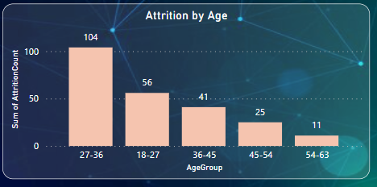

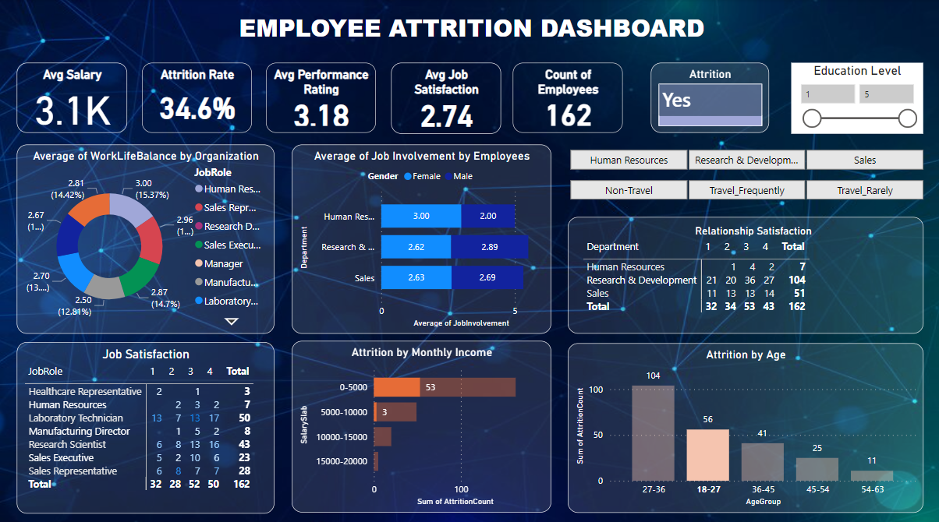

Notably, age emerges as one of the most influential factors in employee turnover. It is observed that the employees belonging to the age group between 18 to 27 convey the highest attrition rate of 34.6% with the lowest average salary of 3.1k. Whereas the employees belonging to age group 36 to 45 show the lowest attrition rate of 9.6% with the highest average salary of 7.0k.

* **MONTHLY INCOME**

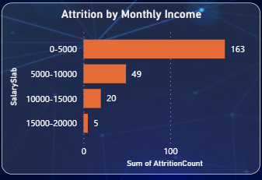

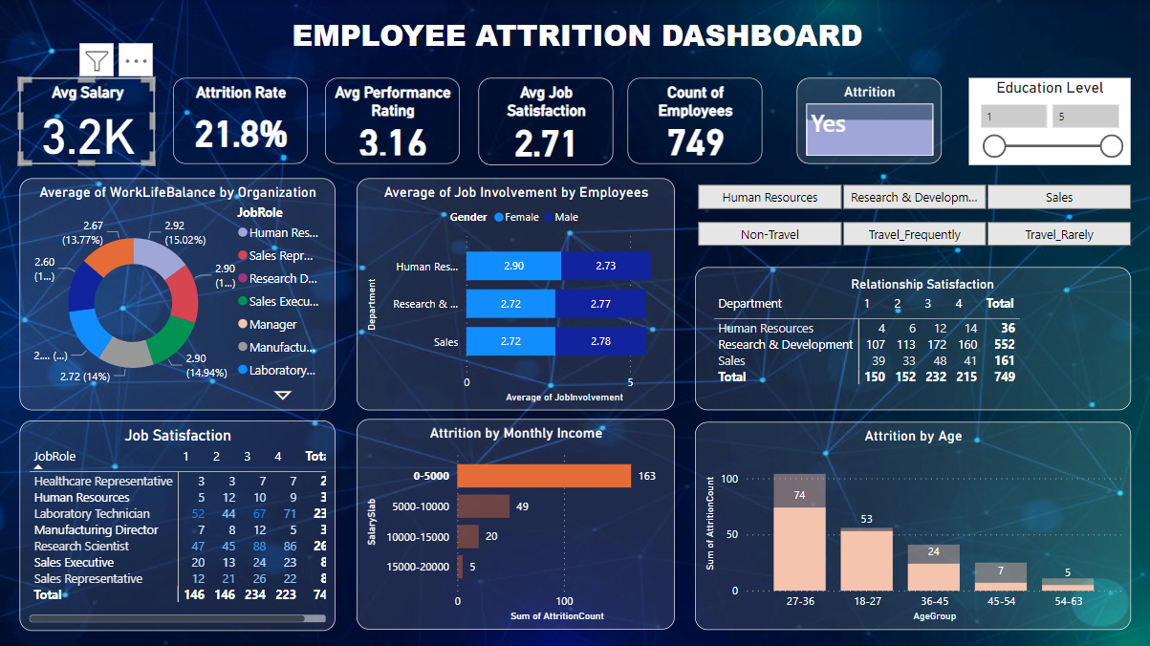

Employees having monthly income below 5.0k are generally leaving the company with the attrition rate of 21.8% which is the highest among all income groups. The reason might be that they have a low average salary of 3.2k which is even less than the company’s average salary.

* **JOB SATISFACTION**

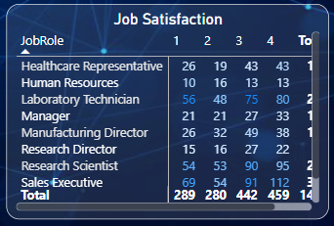

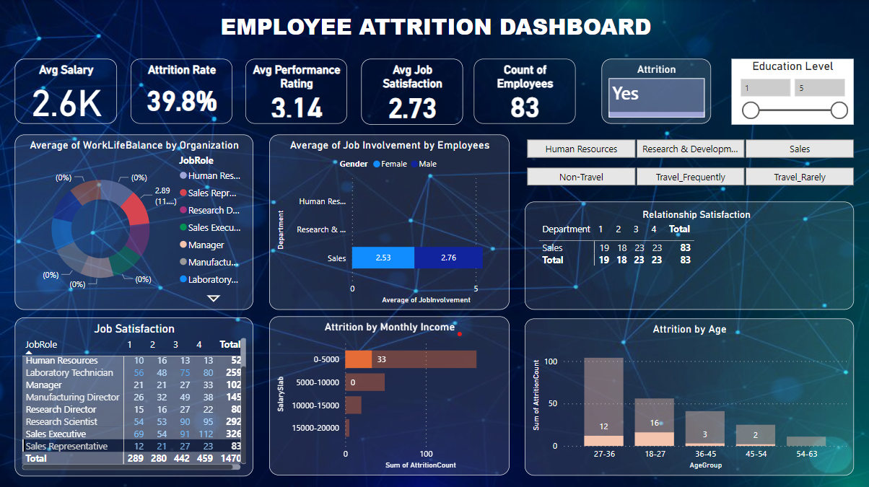

Job satisfaction also helps with employee retention. When employees are happy with their jobs, absenteeism will be reduced. Employees will stay with the organization, reducing turnover. Employees with the job role of sales representative possess the highest attrition rate of 39.8% with a very low average salary of 2.6k.

* **WORK-LIFE BALANCE**

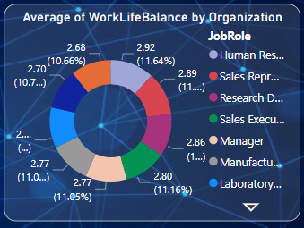

Employees with the job role of research scientist share the lowest fraction of work-life balance (10.66%). In terms of average work-life balance, the employees working as research directors give the lowest average performance rating while the HR employees express the least job satisfaction on average.

* **JOB INVOLVEMENT**

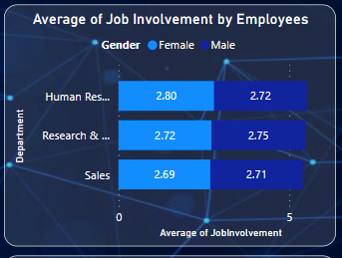

Employees of the sales department represent the lowest degree of involvement in their job for both male and female genders with an attrition rate of 20.6%. The average job involvement ratio of a female to male is nearly the same for all three departments.

* **RELATIONSHIP SATISFACTION**

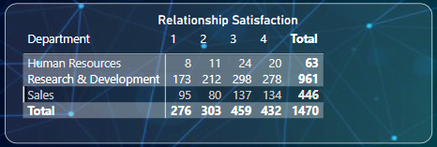

Workplace relationships and interaction have an impact on employee satisfaction and retention. Negative attitudes can lead to isolation and loneliness, which may instigate an employee's desire to resign. Sales employees reveal the lowest level of satisfaction with relationships at the workplace. Concerned with this factor, the sales department has the highest attrition rate of 20.6% out of all three departments.

**THE END**